FORTEC Group Enhances Production Strategy for the U.S. Market

FORTEC Group Offers European Companies with U.S. Customers Cost-Effective Routes into the United States – Thanks to Local Manufacturing and Intelligent Pre-Assembly
Germering (Germany), April 15, 2025 – FORTEC Group, a leading provider of solutions for industrial display, embedded and system solutions, as well as power supplies, enables European companies with U.S. customers to optimize their production chains. By combining local manufacturing in the United States with the strategic pre-assembly of electronic components in Egypt, the company, together with its subsidiaries, provides a cost-effective pathway for the electronics industry to supply the U.S. market.

Thanks to this coordinated production chain, high surcharges are largely eliminated, as products with the corresponding added value are only subject to regular customs duties of currently 10%. This significant difference results in more stable and predictable import costs, thereby enhancing planning certainty even in an internationally volatile trade environment.

In addition to the cost advantages, FORTEC convinces with its efficiency and flexibility in material procurement. The geographical diversification of production sites and local warehousing mitigate the impact of trade sanctions and sudden customs adjustments. As a result, European industrial customers benefit from shorter delivery times, high quality standards, and a predictable cost structure.

“Our global manufacturing strategy protects our customers from unforeseen customs charges and ensures a competitive pricing structure in the long term,” emphasized Ulrich Ermel, Chief Operating Officer of FORTEC Elektronik AG and Managing Director of FORTEC Integrated GmbH. “FORTEC delivers not only technological progress with its innovative solutions but also genuine added value along the entire supply chain.”

This strategic focus demonstrates that FORTEC is responding flexibly and proactively to global challenges, thereby enabling the European electronics industry to offer its products in the United States efficiently, reliably, and competitively.

Words: 295

Keywords: FORTEC Integrated, FORTEC Group, production chain, United States, USA, Egypt, competitiveness

Image

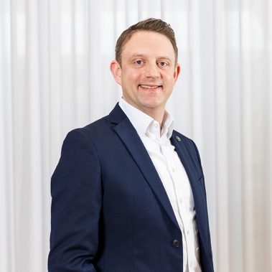 | Ulrich Ermel, Chief Operating Officer of FORTEC Elektronik AG and Managing Director of FORTEC Integrated GmbH  Copyright: FORTEC Integrated  Download: https://www.ahlendorf-news.com/media/news/images/fortec-integrated-ulrich-ermel-h.jpg

About FORTEC Integrated

FORTEC Integrated (formerly Distec) is a FORTEC Group company, a globally active and recognized specialist in the field of display technology and embedded computing for projects from all industries. The company, headquartered in Germering near Munich and with a factory in Hörselberg-Hainich near Eisenach, develops, manufactures, and markets innovative solutions and a wide range of components, TFT displays, embedded boards, systems, and services. The innovative solutions from assemblies and kits to OEM end products are based on hardware and software developed by FORTEC Integrated / Distec in its own design center in Germering. FORTEC Integrated's range of services includes customer-specific developments and adaptations, product refinements such as VacuBond® optical bonding and the assembly of monitor systems, as well as the manufacture of finished products. A wide range of touch screens and the internal touch competence center enable individual touch solutions even for difficult environmental conditions. In addition, FORTEC Integrated can draw on the goods, services, and know-how of the extensive FORTEC high-tech company network. Further information can be found at https://www.fortec-integrated.de/en/

The products of FORTEC Integrated are available at:
Europe: FORTEC Integrated GmbH, Germering, https://www.fortec-integrated.de/en/
UK and Benelux: FORTEC Technology UK, Huntingdon, https://www.fortec.uk/
North America: FORTEC US Corp., Ronkonkoma NY, http://www.fortec.us/

Power Supplies are available at:
FORTEC Power GmbH, Riedstadt, https://www.fortec-power.de/
FORTEC Switzerland AG, Würenlos, https://www.fortec.ch/

FORTEC Integrated GmbH
Augsburger Straße 2b
82110 Germering
Germany
T +49 89 894363 0
F +49 89 894363 131
E info|at|fortec-integrated.de
W www.fortec-integrated.de

A FORTEC Group company

Press contact:
Mandy Ahlendorf
ahlendorf communication
T +49 89 41109402
E ma@ahlendorf-communication.com

